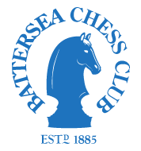

**COMMITTEE MEETING**

**On Monday 13 May 2019 at 7.30pm**

**At The Nightingale, 97 Nightingale Lane, Balham, SW12 8NX**

**AGENDA**

1. Minutes of the last meeting (22 October 2018)
2. Matters arising
3. Finance – update
4. Progress report on Club tournaments and events
5. London League issues

- Quickplay v Slowplay

- Updating of League Rules

1. Summer Chess League
2. Preparation for AGM

- Proposed subscription

- Team entries for next season

- Officers and team captains

- Team selection

- Awards & Game of the Year

1. Juniors

1. Equipment - any new requirements?
2. Any other business